


1st FEBRUARY 2025
CANCELLATION OF MEMBERSHIP
- For Members paying by Direct Debit:
During the first year of membership the member is required to make the initial 6 monthly direct debit payments. Thereafter, membership can be cancelled by submitting written notice to the Club Secretary giving a minimum of 2 months’ notice.

- For Members paying Annually:
Members paying annually can cancel their membership on their annual renewal date. Cancellations during the year will not attract any refund.
GDPR
I have read & understood your privacy statement and agree to you using my personal data in this way.
Signed ___________________ Date ____________

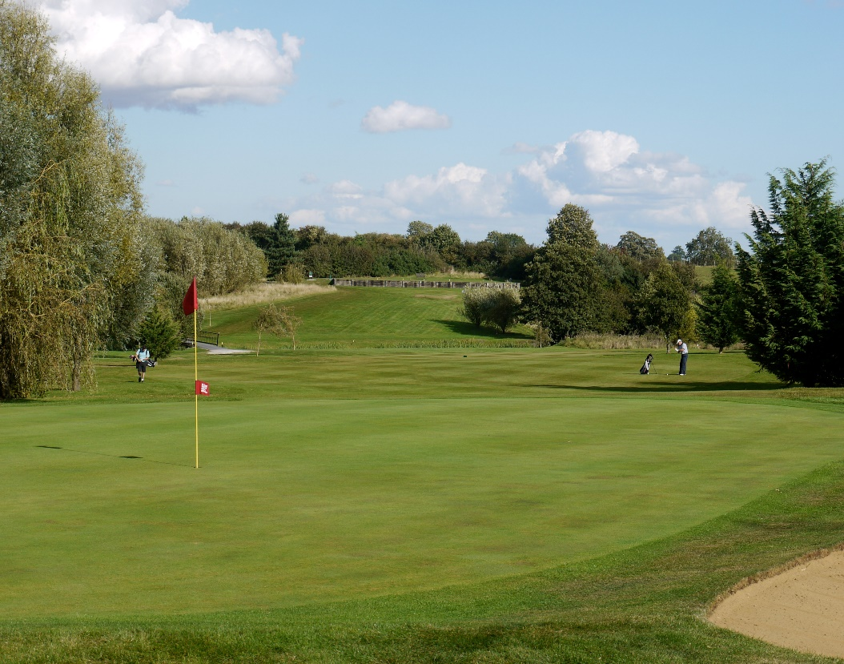
AYLESBURY VALE GOLF CLUB

Aylesbury Vale Golf Club
Stewkley Road, Wing,
Leighton Buzzard, Beds
LU7 0UJ
Tel: 01525 240196
info@avgc.co.uk www.avgc.co.uk

MEMBERSHIP CONTRACT 2025

Membership Number
allocated
Pack-up handed to
Member
Database actioned
BRS actioned
Membership Type |  | 2025 Fees | Spread Payment
7 DAY |  | £1248 | £624 + (6 x £104)
5 DAY |  | £930 | £465 + (6 x £77.50)
Husband/Wife 7 DAY |  | £1980 | £990 + (6 x £165)
Husband/Wife 5 DAY |  | £1464 | £732 + (6 x £122)
2 Years at 5% discount |  | 2 X annual fee Less 5% | N/A
3 Years at 8% discount |  | 3 X annual fee Less 8% | N/A
JUNIOR - Red tee* (12 TO 18) |  | £245 | N/A
JUNIOR - Blue tee* (Under 12) |  | £150 | N/A
UNI or COUNTRY 5DAY  (Living over 50 miles away) |  | £375 | N/A
PAYMENT OPTIONS
 | ANNUALLY: I have chosen to pay my annual membership in advance by cash/cheque/credit or debit card
 | I have chosen to pay my annual membership by the SPREAD PAYMENT OPTION and have completed my Direct Debit mandate

Your Details
Forename/s: Surname:
Address:

Postcode: Handicap: CDH:
Mobile: Home:
Email:
Date of Birth (Junior/Young Golfer):
Car Reg; Number 1 2 3 . .
All of the above fees are fully inclusive of England Golf and County affiliation fees at £23.50, and inclusive of VAT.

I accept the conditions of membership as listed in the Club Handbook. *Half price for children of Husband/Wife members.
Signed Date

Aylesbury Vale Golf Club is a picturesque 18 hole golf course with a par of 72, measuring 6593 yards from the competition tees. Membership provides the opportunity to enter many and varied club competitions. There are a range of discounts for members on shop goods, buggies and driving range tokens as well as 10% off catering and drinks. We offer a members discount on our superb function room, with the ability to cater for over 100. Our clubhouse has a warm and friendly atmosphere and our resident chef provides hot and cold meals and some tempting special offers to suit every taste.
Membership of the Smartgolfer Network is INCLUDED for adult members and entitles you to two free rounds of golf each year at each of the 30 other clubs. Members of Aylesbury Vale Golf Club are also entitled to sign in guests at a reduced green fee. We also offer 3 years membership at an 8% discount, or 2 years at a 5% discount. Please enquire for more details.
The golf membership contract and member’s handbook will detail the regulations regarding membership and outline the current membership rates. The information provided will be held for record purposes only and will not be divulged to any third party.

